A Real Time and Interactive Dashboard in Tourism Industry

Software Requirement Specification

By

Junyu Zhou 592115508

Yawei Li 592115518

Department of Software Engineering,

College of Arts, Media and Technology,

ChiangMai University

Project Advisor



Table of Contents

1. Document History 3

2. Introduction 4

2.1 Purpose 4

2.2 Project Overview 4

2.3 User Characteristics 5

2.4 Operation Environment 6

2.5 Acronyms and Definitions 6

3. Project Feature 9

4. User requirement specification 11

4.1 User Requirement Analysis 11

4.2 User Requirement Specification 11

5. Specific Requirement 13

5.1 Use Case Scenario 13

5.2 Use Case Description 17

# 1. Document History

|  |  |  |  |  |  |
| --- | --- | --- | --- | --- | --- |
| History | Status | Date | Viewable | Editable | Responsible |
| A Real Time and Interactive Dashboard in Tourism Industry  Create:  - user requirement specification  - system requirement specification | Draft | June 29, 2019 | ZJY, LYW,  AJP | ZJY, LYW | ZJY, LYW |
|  |  |  |  |  |  |

ZJY = Junyu Zhou

LYW = Yawei Li

AJP = Dr. Pree Thiengburanathum

# 2. Introduction

## 2.1 Purpose

The purpose of the software requirement specification (SRS) is to describe the functional and non-functional requirements of a real time and interactive dashboard in tourism industry. The requirements in the SRS are involved with the users to use the web-based application. The software requirement specification provides developers and users to understand each other in structure details. The application will be designed followed the SRS.

## 2.2 Project Overview

A real time and interactive dashboard in tourism industry is developed for the decision maker to view and manage the data easily and efficiently. Due to a large number of data, there are numerous work and extra things to do for doing statistics. A real time and interactive dashboard in tourism industry will provide the effective platform to decision maker to manage and statistics the massive data.

**2.2.1 Project Scope**

A real time and interactive dashboard in tourism industry is a web-based application. It is for decision maker to do the easy statistics of mess data in a real time way. For decision maker to manage and keep tracks all the data.

**2.2.2 Document Scope**

This document will include use case, use case description and software requirement of A real time and interactive dashboard in tourism industry. The scope of use case will cover the dashboard system and login/logout system.

Use case diagrams are usually referred to as behavior diagrams used to describe a set of actions (use cases) that some system or systems (subject) should or can perform in collaboration with one or more external users of the system (actors).

A software requirements specification (SRS) is a comprehensive description of the intended purpose and environment for software under development. The SRS fully describes what the software will do and how it will be expected to perform.

## 2.3 User Characteristics

This system provides visualization data for decision makers easily to do statistics. In addition, A real-time and interactive dashboard in tourism industry will provide more than one types of visualization for users (for example, heatmap, word cloud)), they will reduce the paper-based work and record all data in an understandable way.

In this application we have two actors following:

**2.3.1 The decision maker**

The decision maker is the people who will use the admin dashboard.

**2.3.2 The user**

The user is the people who will write and view comments.

## 2.4 Operation Environment

PyCharm

Visual Studio Code

MongoDB

Pusher

React

Flask

GitHub

Draw.io

## 2.5 Acronyms and Definitions

**2.5.1 Acronyms**

ZJY = Junyu Zhou

LYW = Yawei Li

AJP = Dr. Pree Thiengburanathum

UC = Use Case

URS = User Requirement Specification

SRS = System Requirement Specification  
AD = Activity Diagram

CD = Class Diagram

**2.5.2 Definitions**

|  |  |
| --- | --- |
|  | Description |
| Use case | (1) A use case is a software and system engineering term that describes how a user uses a system to accomplish a particular goal. A use case acts as a software modeling technique that defines the features to be implemented and the resolution of any errors that may be encountered. [1]( <https://www.techopedia.com/definition/25813/use-case>) |
| Requirement | (1)A condition or capability needed by the user to solve a problem or achieve an objective for project.  (2) A condition or capability that must be met or possessed by a system or system component to satisfy a contract, standard, specification, or other formally imposed document. [2] (<https://en.wikipedia.org/wiki/Software_requirements>) |
| Specification | Description of an activity or work product that serves as the basis or input for further activities or work product. A specification can comprise requirements to a Product and how they will be solved. [3]( <https://books.google.co.th/books?id=dZTaRee1PXMC&pg=PA534&lpg=PA534&dq=Description+of+an+activity+or+work+product+that+serves+as+the+basis+or+input+for+further+activities+or+work+product.+A+specification+can+comprise+requirements+to+a+Product+and+how+they+will+be+solved.&source=bl&ots=OHePmeIc05&sig=ACfU3U02RfmAjmc6dJNONRAaT7TANIRIvw&hl=zh-CN&sa=X&ved=2ahUKEwiW0dyCopjjAhVKLY8KHa6GCVoQ6AEwAXoECAkQAQ#v=onepage&q=Description%20of%20an%20activity%20or%20work%20product%20that%20serves%20as%20the%20basis%20or%20input%20for%20further%20activities%20or%20work%20product.%20A%20specification%20can%20comprise%20requirements%20to%20a%20Product%20and%20how%20they%20will%20be%20solved.&f=false>) |
| User Interface | Visual part of computer application or operating system through which a user interacts with a computer or a software. It determines how commands are given to the computer or the program and how information is displayed on the screen. [4]( <http://www.businessdictionary.com/definition/user-interface.html>) |

# 3. Project Feature

**Feature-1. Login**

• Decision maker could log in to the system.

**Feature-2. View the summary of data visualization result**

• Decision maker could view the data summary (word frequency bar chart, number of comments histogram, types of comments Stacked column chart, positive comments rate line chart) on the dashboard.

**Feature-3. View the word-cloud of data**

• The decision maker could view the data presented in word-cloud.

**Feature-4. View the heatmap of data**

• The decision maker could view the data presented in a heatmap.

**Feature-5. View the data by name, date, sentiment or search for reviews**

• The decision maker could view data by select the filter or input name.

**Feature-6. Log out**

• The decision maker could log out from the dashboard.

**Feature-7. View comments**

• User could view comments.

**Feature-8. Write comments**

• User could write comments.

# 4. User requirement specification

## 4.1 User Requirement Analysis

## 4.2 User Requirement Specification

**Feature-1. Login**

URS-01: Decision maker inputs username and password to login to the dashboard.

**Feature-2. View the summary of data visualization result**

URS-02: Decision maker views data summary on the homepage.

**Feature-3. View the word-cloud of data**

URS-03: Decision maker views data by word-cloud.

**Feature-4. View the heatmap of data**

URS-04: Decision maker views data by heatmap.

**Feature-5. View the data by name, date, sentiment or search for reviews**

URS-05: Decision maker views data by inputting name.

URS-06: Decision maker views data by selecting date.

URS-07: Decision maker selects sentiment to view.

URS-08: Decision maker searches reviews.

**Feature-6. Log out**

URS-09: Decision maker logs out from the dashboard.

**Feature-7. View comments**

URS-10: User views comments.

**Feature-8. Write comments**

URS-10: User writes comments.

# 5. Specific Requirement

## 5.1 Use Case Scenario

**5.1.1 Use Case Diagram of Feature 1 &Feature 6**

**Decision maker:**

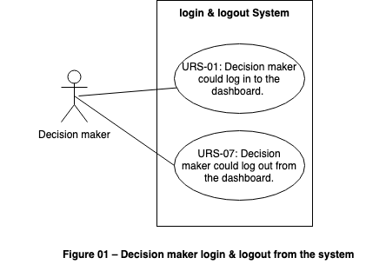

**5.1.2 Use Case Diagram of Feature 2**

**Decision maker:**

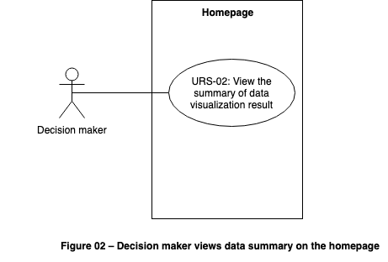

**5.1.3 Use Case Diagram of Feature 3**

**Decision maker:**

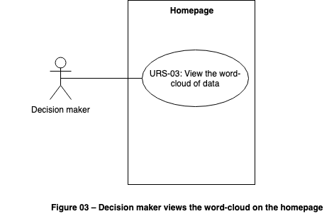

**5.1.4 Use Case Diagram of Feature 4**

**Decision maker:**

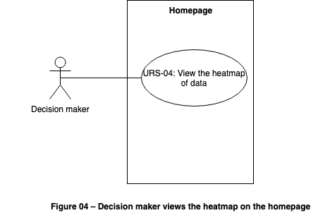

**5.1.5 Use Case Diagram of Feature 5**

**Decision maker:**

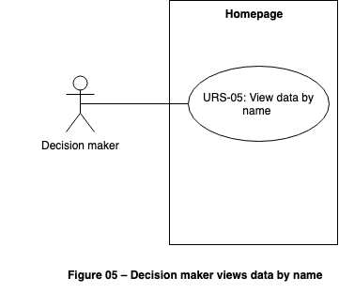

**5.1.6 Use Case Diagram of Feature 6**

**Decision maker:**

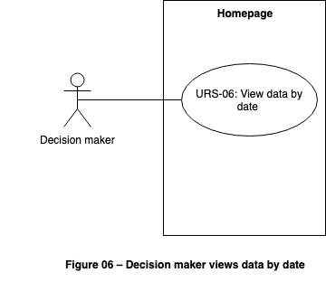

**5.1.7 Use Case Diagram of Feature 7**

**Decision maker:**

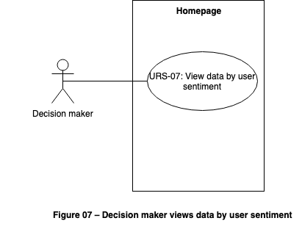

**5.1.8 Use Case Diagram of Feature 8**

**Decision maker:**

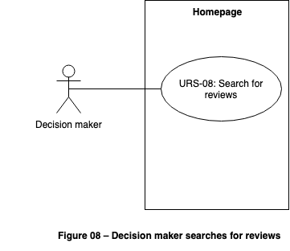

## 5.2 Use Case Description

**5.2.1 login & logout System**

|  |  |  |  |  |
| --- | --- | --- | --- | --- |
| Use Case ID | UC-01 | | | |
| Use Case Name | Login to the system | | | |
| Actors | Decision maker | | | |
| Description | Decision maker can login to the system by input username and password. | | | |
| Trigger | Decision maker clicks “Login” button. | | | |
| Preconditions | System connect with internet successful. | | | |
| Use Case Input Specification | | | | |
| Input | type | Constraint | | Example |
| Username | String | - Must contain characters and numbers and not more than 10 digits.  - No special characters and space. | | Admin001 |
| Password | String | - Not less than 6 digits. | | Admin001 |
| Post conditions | Decision maker login to dashboard successful. | | | |
| Normal Flows | User | | System | |
|  |  | | 1. System provides the login interface. | |
|  | 2. Decision maker inputs username and password. | |  | |
|  |  | | 3.System validates that the username and password. [A1] | |
| Alternative Flow | A1: Username and password do not match.  1: Display: “The username or password is not correct.”  2: System goes to 1st step in normal flows. | | | |
| Exception Flow |  | | | |
| Assumption | Decision maker must have an individual account. | | | |

|  |  |  |  |  |
| --- | --- | --- | --- | --- |
| Use Case ID | UC-02 | | | |
| Use Case Name | View the summary | | | |
| Actors | Decision maker | | | |
| Description | Decision maker can view the summary of data visualization result. | | | |
| Trigger | Decision maker logged in successful. | | | |
| Preconditions | Decision maker must login into the system. | | | |
| Use Case Input Specification | | | | |
| Input | type | Constraint | | Example |
|  |  |  | |  |
| Post conditions | Decision maker can view the summary page. | | | |
| Normal Flows | User | | System | |
|  |  | | 1.System displays the word frequency bar chart, number of comments histogram, types of comments Stacked column chart and positive comments rate line chart. [E1] | |
| Alternative Flow |  | | | |
| Exception Flow | E1: Cannot connect to database.  1: Display: “Cannot connect to database.”  2: System provides a button to refresh. | | | |
| Assumption | Decision maker must have an individual account. | | | |

|  |  |  |  |  |
| --- | --- | --- | --- | --- |
| Use Case ID | UC-03 | | | |
| Use Case Name | View the Word-Cloud | | | |
| Actors | Decision maker | | | |
| Description | Decision maker can view the Word-Cloud of data. | | | |
| Trigger | Decision maker clicks “Word-Cloud” button. | | | |
| Preconditions | Decision maker must login into the system. | | | |
| Use Case Input Specification | | | | |
| Input | type | Constraint | | Example |
|  |  |  | |  |
| Post conditions | Decision maker can view the Word-Cloud page. | | | |
| Normal Flows | User | | System | |
|  | 1.Decision maker clicks the “Word-Cloud” button. | |  | |
|  |  | | 2. System displays the Word-Cloud. [E1] | |
| Alternative Flow |  | | | |
| Exception Flow | E1: Cannot connect to database.  1: Display: “Cannot connect to database.”  2: System provides a button to refresh. | | | |
| Assumption | Decision maker must have an individual account. | | | |

|  |  |  |  |  |
| --- | --- | --- | --- | --- |
| Use Case ID | UC-04 | | | |
| Use Case Name | View the Heatmap | | | |
| Actors | Decision maker | | | |
| Description | Decision maker can view the Heatmap of data. | | | |
| Trigger | Decision maker clicks “Heatmap” button. | | | |
| Preconditions | Decision maker must login into the system. | | | |
| Use Case Input Specification | | | | |
| Input | type | Constraint | | Example |
|  |  |  | |  |
| Post conditions | Decision maker can view the Heatmap page. | | | |
| Normal Flows | User | | System | |
|  | 1.Decision maker clicks the “Heatmap” button. | |  | |
|  |  | | 2. System displays the Heatmap. [E1] | |
| Alternative Flow |  | | | |
| Exception Flow | E1: Cannot connect to database.  1: Display: “Cannot connect to database.”  2: System provides a button to refresh. | | | |
| Assumption | Decision maker must have an individual account. | | | |

|  |  |  |  |  |
| --- | --- | --- | --- | --- |
| Use Case ID | UC-05 | | | |
| Use Case Name | View by name | | | |
| Actors | Decision maker | | | |
| Description | Decision maker can view the data by inputting name. | | | |
| Trigger | Decision maker selects to view by inputting name. | | | |
| Preconditions | Decision maker must login into the system. | | | |
| Use Case Input Specification | | | | |
| Input | type | Constraint | | Example |
| Name | String | - Must more than 0 characters.  - Must less than 20 characters | | CAMT |
| Post conditions | Decision maker can view the data by inputting name. | | | |
| Normal Flows | User | | System | |
|  | 1. Decision maker clicks the search bar. | |  | |
|  | 2. Decision maker inputs name. | |  | |
|  |  | | 3. System searches in database. [E1] | |
|  |  | | 4. System displays results. | |
| Alternative Flow |  | | | |
| Exception Flow | E1: Cannot connect to database.  1: Display: “Cannot connect to database.”  2: System provides a button to refresh. | | | |
| Assumption | Decision maker must have an individual account. | | | |

|  |  |  |  |  |
| --- | --- | --- | --- | --- |
| Use Case ID | UC-06 | | | |
| Use Case Name | View by date | | | |
| Actors | Decision maker | | | |
| Description | Decision maker can view the data by date. | | | |
| Trigger | Decision maker selects to view by dragging a date bar. | | | |
| Preconditions | Decision maker must login into the system. | | | |
| Use Case Input Specification | | | | |
| Input | type | Constraint | | Example |
|  |  |  | |  |
| Post conditions | Decision maker can view the data by dragging a date bar. | | | |
| Normal Flows | User | | System | |
|  | 1. Decision maker drags a date bar. | |  | |
|  |  | | 2. System searches in database. [E1] | |
|  |  | | 3. System displays results. | |
|  |  | |  | |
| Alternative Flow |  | | | |
| Exception Flow | E1: Cannot connect to database.  1: Display: “Cannot connect to database.”  2: System provides a button to refresh. | | | |
| Assumption | Decision maker must have an individual account. | | | |

|  |  |  |  |  |
| --- | --- | --- | --- | --- |
| Use Case ID | UC-07 | | | |
| Use Case Name | View data by user sentiment. | | | |
| Actors | Decision maker | | | |
| Description | Decision maker can view the data by selecting sentiment. | | | |
| Trigger | Decision maker selects to view by selecting sentiment. | | | |
| Preconditions | Decision maker must login into the system. | | | |
| Use Case Input Specification | | | | |
| Input | type | Constraint | | Example |
|  |  |  | |  |
| Post conditions | Decision maker can view the data by selecting sentiment. | | | |
| Normal Flows | User | | System | |
|  | 1. Decision maker selects the sentiment list. | |  | |
|  |  | | 2. System searches in database. [E1] | |
|  |  | | 3. System displays results. | |
|  |  | |  | |
| Alternative Flow |  | | | |
| Exception Flow | E1: Cannot connect to database.  1: Display: “Cannot connect to database.”  2: System provides a button to refresh. | | | |
| Assumption | Decision maker must have an individual account. | | | |

|  |  |  |  |  |
| --- | --- | --- | --- | --- |
| Use Case ID | UC-08 | | | |
| Use Case Name | Search reviews | | | |
| Actors | Decision maker | | | |
| Description | Decision maker can search reviews. | | | |
| Trigger | Decision maker selects to search by inputting reviews. | | | |
| Preconditions | Decision maker must login into the system. | | | |
| Use Case Input Specification | | | | |
| Input | type | Constraint | | Example |
| Reviews | String | - Must more than 0 characters. | | Fabulous |
| Post conditions | Decision maker can search reviews. | | | |
| Normal Flows | User | | System | |
|  | 1. Decision maker clicks the search bar. | |  | |
|  | 2. Decision maker inputs reviews. | |  | |
|  |  | | 3. System searches in database. [E1] [A1] | |
|  |  | | 4. System displays results. | |
| Alternative Flow | A1: Reviews don’t exist in database.  1: Display: “The review doesn’t exist in database.”  2: System goes to 1st step in normal flows. | | | |
| Exception Flow | E1: Cannot connect to database.  1: Display: “Cannot connect to database.”  2: System provides a button to refresh. | | | |
| Assumption | Decision maker must have an individual account. | | | |

|  |  |  |  |  |
| --- | --- | --- | --- | --- |
| Use Case ID | UC-09 | | | |
| Use Case Name | Log out to the system | | | |
| Actors | Decision maker | | | |
| Description | Decision maker can log out to the system. | | | |
| Trigger | Decision maker clicks “Log out” button. | | | |
| Preconditions | System connect with internet successful. | | | |
| Use Case Input Specification | | | | |
| Input | type | Constraint | | Example |
|  |  |  | |  |
| Post conditions | Decision maker login out successful. | | | |
| Normal Flows | User | | System | |
|  |  | | 1. System provides the log out interface. | |
|  | 2. Decision maker clicks log out button. | |  | |
|  |  | | 3.System log out to the system. | |
| Alternative Flow |  | | | |
| Exception Flow |  | | | |
| Assumption | Decision maker must have an individual account. | | | |

|  |  |  |  |  |
| --- | --- | --- | --- | --- |
| Use Case ID | UC-10 | | | |
| Use Case Name | View reviews | | | |
| Actors | All users | | | |
| Description | Users can view reviews. | | | |
| Trigger | Users visit homepage. | | | |
| Preconditions | System connect with internet successful. | | | |
| Use Case Input Specification | | | | |
| Input | type | Constraint | | Example |
|  |  |  | |  |
| Post conditions | Users view reviews. | | | |
| Normal Flows | User | | System | |
|  |  | | 1. System displays reviews from database. [E1] | |
|  |  | |  | |
|  |  | |  | |
| Alternative Flow |  | | | |
| Exception Flow | E1: Cannot connect to database.  1: Display: “Cannot connect to database.”  2: System provides a button to refresh. | | | |
| Assumption | Decision maker must have an individual account. | | | |

|  |  |  |  |  |
| --- | --- | --- | --- | --- |
| Use Case ID | UC-11 | | | |
| Use Case Name | Write reviews | | | |
| Actors | All users | | | |
| Description | Users can write reviews. | | | |
| Trigger | Users visit homepage. | | | |
| Preconditions | System connect with internet successful. | | | |
| Use Case Input Specification | | | | |
| Input | type | Constraint | | Example |
| Reviews | String | - Must more than 0 characters. | | Fabulous |
| Post conditions | Users write reviews. | | | |
| Normal Flows | User | | System | |
|  |  | | 1. System provides the write review interface. | |
|  | 2. Users input reviews. | |  | |
|  |  | | 3.System records and shows reviews [E1] | |
| Alternative Flow |  | | | |
| Exception Flow | E1: Cannot connect to database.  1: Display: “Cannot connect to database.”  2: System provides a button to refresh. | | | |
| Assumption | Decision maker must have an individual account. | | | |